**CS140 - Introduction to Computing**

**Week 1 - Practice Lab - 0 points**

**Topics: Learning the Compiler**

Log on and start Visual C++ .NET. Create a new project called **Lab1**. Type the following program as is and try to correct all the errors, both syntax and logic, on your own. Run the program. If you encounter any difficulties you may seek help from your instructor or lab assistant.

// Name: <your name here>

// CS140 Lab Section <your lab section>

// File: Lab1.cpp

#include <iostream>

#using namespace std;

void main()

{

     int today; yearOfBirth;

     cout << "Programmed by <your name here>" << endl;

     cout << "Enter the current year: ""

     cin >>> today;

     cout << "Enter your year of birth;

     cin >> YearOfBirth;

     cout << endl << "Oh my, you are "

         << YearOfBirth - today

         << "years old"

         << endl;

}// end of main()

Upload this .cpp file (remember you will ALWAYS only be uploading the cpp file!), to the dropbox (*classes.cs.siue.edu*) assignment Lab1. This will not be for credit, however you should do it for practice.

**CS140 - Introduction to Computing I**

**Week 2 - 0 points**

**Topics: Practice the Compiler, Simple I/O**

Your are to write a program to ask the user to type in their initials, age and height.

Sample output is given below. You should be able to determine from the output what type variable should be used to store the information. Your program's output should be identical to the ones shown below.

Electronic Submission: You are to electronically submit your .cpp file to Lab2 using the course website at *classes.cs.siue.edu*.

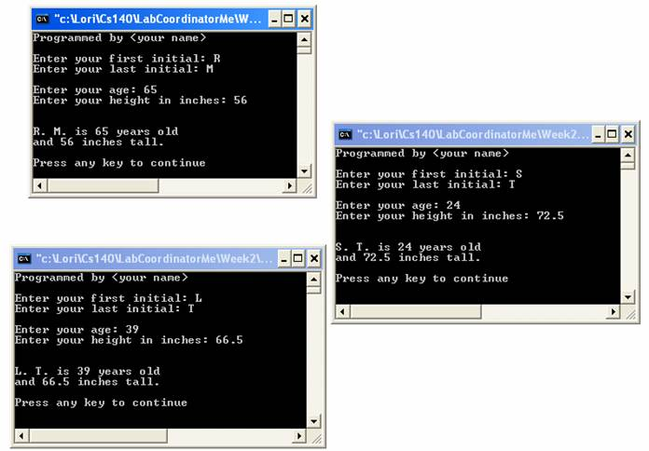

**CS140 - Introduction to Computing I**

**Week 3 - 100 points**

**Objectives**

* Assignment statement
* Arithmetic Expressions
* Simple I/O
* Simple if...else

**Problem Description**

Write a program that computes the amount of fine a driver must pay for a speeding violation. The program must ask for the speed limit and the driver's speed, and then compute the fine based on the following information:

* if driver's speed is 1-10 mph over the speed limit, then the fine is $55
* if driver's speed is 11-25 mph over the speed limit, then the fine is $75
* if driver's speed is 26-35 mph over the speed limit, then the fine is $110
* if driver's speed is over 35 mph, over the speed limit, then the fine is $175

**Program Requirements**

* Your program's output should exactly match the output shown below in the screenshots.
* Assume all input values will be positive.
* Assume the driver's speed will be higher than the speed limit.
* You are to electronically submit your source file (.cpp) to the *Lab3* folder using the course web site at *classes.cs.siue.edu.*

**CS140 - Introduction to Computing I**

**Week 5 - 100 points**

**Topics: Basic Looping (switch, if..elseif..else)**

You are to write a program to determine the cost of a new carpet. The only areas that the company is capable of carpeting are circles, rectangles or right triangles. First your program will ask the user whether the area to be carpeted is a circle, rectangle or a right triangle. Then your program will compute the area. Finally, the program will compute and print out the cost of the rug. If 150 or more square feet are being carpeted, the cost per square foot is $11.95. If less than 150 square feet, but 75 or more square feet are being carpeted, the cost per square foot is $12.35. If there is less than 75 square feet being carpeted the cost per square foot is $13.28.

Requirements

There should be 4 global constants (three prices, and pi [3.14159])

A switch statement must be used to determine which input and area calculation is needed.

Answers should have two digits of precision.

Sample output is given below. Your program's output should be identical to the ones shown below.

Electronic Submission: You are to electronically submit your .cpp file to Lab5 using the course website at *classes.cs.siue.edu*.

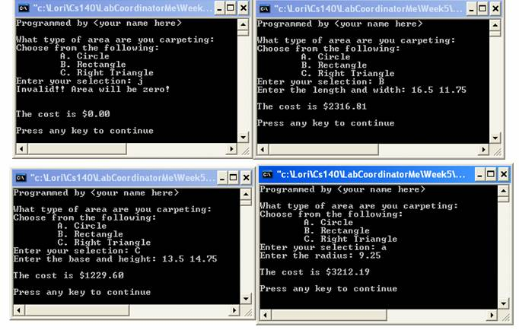

**CS140 : Introduction to Computing I**

**Week 6 : 100 points**

**Topics: Strings**

Write a program that allows the user to type one line of text. Your program should store that line into a string. Your program will print out the line of text, then print out all of the capital letters, and then print out the line of text again. You will use the string class.

Sample output is given below.

Electronic Submission: You are to electronically submit your .cpp file to Lab6 using the course website at classes.cs.siue.edu.

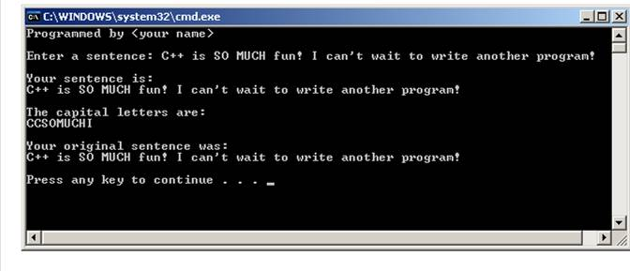

**CS140 - Introduction to Computing I**

**Week 8 - 100 points**

**Topics: Built-In Functions**

Write a program that asks the user to type in three **integers** and then solves the following mathematical expression. It should continue asking the user for more integers until the user chooses to quit.

Answer = 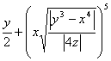

Requirements:

All three variables must be integers.

Answer should have 4 digits of precision.

You must use a built in functions **for all powers**.

Sample output is given below. Your program's output should be identical to the ones shown below.

Electronic Submission: You are to electronically submit your .cpp file to Lab 8 using the course web site at *classes.cs.siue.edu*

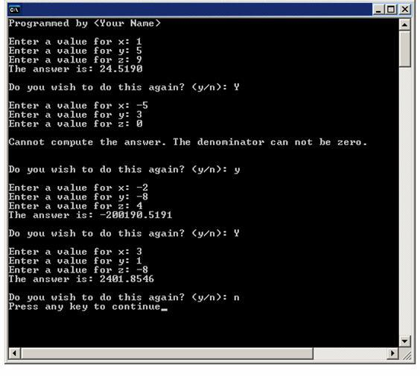

**CS140 - Introduction to Computing I**

**Week 10 - 100 points**

**Topics: Basic User Defined Functions/ Pass by Value Functions**

You are to write a program to determine the grade received on a test. The program should ask the user to type in the number of questions they got correct and the number of questions on the test. It should then compute the grade. The program should continue computing grades until the user types a negative number to exit.

Requirements

One function, **calculateGrade**, that returns the grade (you should be able to determine what formal parameters are needed.)

One function,**enterTotalQuestions**, that asks the user to enter the total number of questions. It should have one integer formal parameter. It should error check the input value to make sure that a number at least as big as the formal parameter is entered. The input value should be returned.

Answers should have one digit of precision.

Sample output is given below. Your program's output should be identical to the ones shown below.

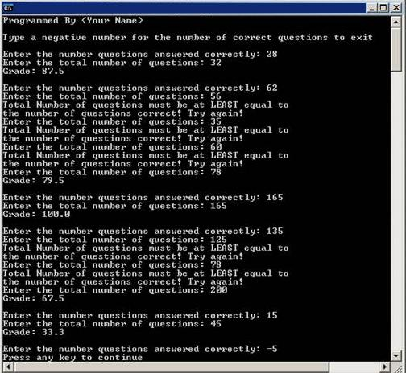Electronic Submission: You are to electronically submit your .cpp file to Lab10 using the course website a

**CS140 - Introduction to Computing I**

**Week 11 - 100 points**

**Topics: User Defined Functions/ Pass by Reference**

You are to write a program to determine the grade received on a test and to print whether the grade is passing or failing. The program should ask the user to type in the number of questions they got correct and the number of questions on the test. It should then compute the grade, determine if it is a passing grade, and determine the letter grade. A passing grade is a grade of 59.5 or higher. The program should continue computing grades until the user types a negative number to exit.

The program should have three functions, one to enter the information, one to compute the grade and determine if the grade is passing, and a third to print out all the results.

Requirements

* This lab uses the "Week11LabB.cpp" file. Get it from the Week 11 page. You may NOT add anything to the main function in this file.
* Answers should have one digit of precision.
* When entering the total number of questions, the user should enter something equal to, or more than the number of questions answered correctly.

Electronic Submission: You are to electronically submit your .cpp file to Lab11 using the course website at [classes.cs.siue.edu](http://www.cs.siue.edu/csd).

